008 TypeScript - operators

TypeScript Kata List – Blog Page

[TypeScript Kata List on GitHub](https://github.com/robertdunaway/katas-typescript)

# Duration

10 minutes

# Brief

Using many types of operators.

### For More Information

BING/GOOGLE: “TypeScript operators”

# Instructions

Get tutorial folder or the entire katas-typescript repo.

Open the [before/*.sln] file and execute the kata.

Feel free to execute this kata multiple times because repetition creates motor memory.

# Github

* Before (start kata with this)
  + https://github.com/robertdunaway/katas-typescript/tree/master/008%20TypeScript%20-%20operators/before
* After
  + https://github.com/robertdunaway/katas-typescript/tree/master/008%20TypeScript%20-%20operators/after

# Kata

Create two variables of type number. These can be used throughout this kata.

var a: number = 10;

var b: number = 5;

Output to the console the addition, subtraction, multiplication, and division of these numbers.

[highlight below for one possible answer]

console.log('a + b = ' + (a + b));

console.log('a - b = ' + (a - b));

console.log('a * b = ' + (a * b));

console.log('a / b = ' + (a / b));

Output to the console the remainder of two divided numbers that yield no remainder and again where a remainder is present.

Tip: The % operator is used.

[highlight below for one possible answer]

console.log('a % b = ' + (a % b));

console.log('a % b = ' + (a % 6));

Increment and decrement “a” with operators.

[highlight below for one possible answer]

a++;

console.log('a++ = ' + a);

a--;

console.log('a-- = ' + a);

a--;

console.log('a-- = ' + a);

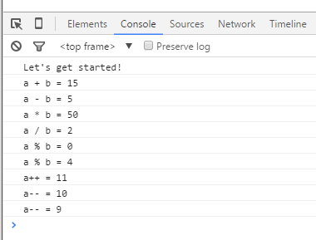

# Next

Take a few minutes and imagine more examples.